C T PUBLIC SCHOOL
Session - 2021-22
SYLLABUS UNIT TEST-1
CLASS - IV

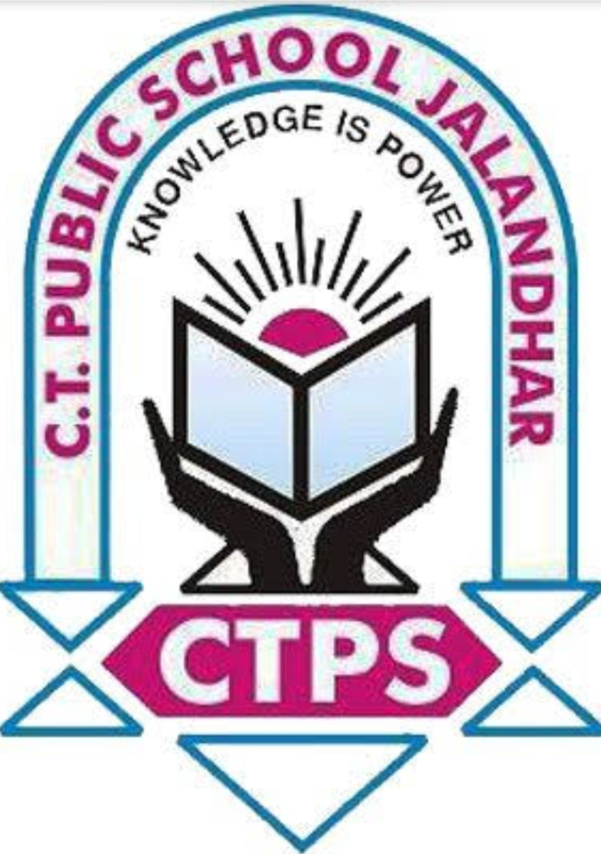

Class - IV
Syllabus of Unit Test -1
Session : 2021-22

Subject: EVS
Unit 1: Organs and Organ systems
(Worksheet 9-16)
Unit 2: Habitat and àdaptation (Worksheet 1to 7)

Subject -ELGA
Unit-1
Chapter : 'There is always a way'
Unit-2
Chapter : 'Kapil's big game'
Chapter : 'Where is bhikhu'

Grammar
Subject verb agreement(Singular or plural nouns)
Identify main verb and helping verbs
Identify adverbs
Differentiate between adverbs and adjectives.

Writing
Elements of story
sequencing of story
Comprehension passage
whole words

Subject Hindi

1. पाठ : जय जवान
2. पाठ : जय विज्ञान
3. पाठ : मैं भी सितारा बन गया
4. पाठ : डिएगो मेराडोना

व्याकरण
- लिंग
- संज्ञा

Subject : Maths

Unit 1 : Large Numbers & Addition
Worksheet 1 to 24
Unit 2 : Subtraction & Multiplication of Large Numbers
Worksheet 1 to 19

Subject : Punjabi
- ਪਾਠ -1 ਕਾਗਜ਼
- ਪਾਠ -2 ਮਜ਼ਾਕ
- ਪਾਠ -5 ਮਿੱਤਰਤਾ
- ਲਿੰਗ ਬਦਲੋ
- ਵਚਨ ਬਦਲੋ

Subject-CCS

UNIT 1- Health Report Card
UNIT 2- Habit Stacking

