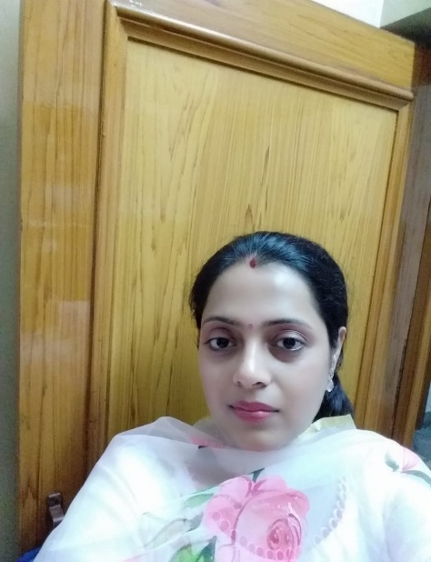
Corona virus has caused pandemic in world. Humanity has lost thousands of lives. Education to society about this menace is only cure. social distancing, personal hygiene is need of this hour. teaching about this to children will be the great service to society. Teacher can make a difference in this crucial time.

Geetika
Maths Teacher

