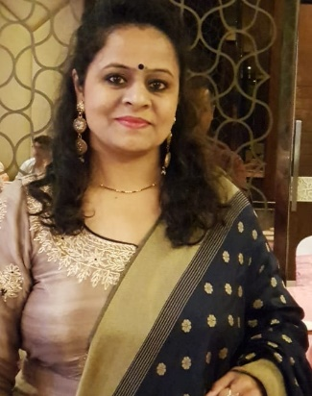

Education plays a very important role in everyone's life. It is very important to get proper education in the same way as the healthy body needs food to achieve success and happiness. It helps us to learn new things and develop a sense of innovation and creativity. We can have education by various methods like teaching, training and research activities. Storytelling is also a method of education which helps to pass the knowledge from one generation to another. Education improves one’s knowledge, skills and develops the personality and attitude. Education improves and refines the speech of a person. It helps in the development and innovation of technology. Most noteworthy, the more the education, the more technology will spread. Education is a ray of light in the darkness. It certainly is a hope for a good life. It is a basic right of every Human on this Planet. To deny this right is evil.

Rimple Bhalla
Hindi Teacher

