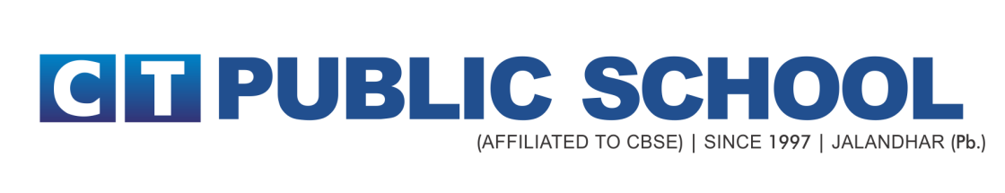
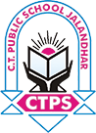

SENIOR SECONDARY SCHOOL EXAMINATION

TERM 1 (2021-22) Minor Subjects Datesheet
Date | Day | Subject
17-11-21 | Wednesday | Financial Markets Management
27-11-21 | Saturday | Punjabi
29-11-21 | Monday | Music
06-12-21 | Monday | Applied Mathematics
27-12-21 | Monday | Painting

CLASS XII DATE SHEET- MAJOR SUBJECTS

DAY, DATE AND TIME | SUBJECT CODE | SUBJECT NAME

FRIDAY, 3rd DECEMBER, 2021
11:30 AM – 1:00 PM | 301 | ENGLISH CORE

MONDAY, 6th DECEMBER, 2021
11:30 AM – 1:00 PM | 041 | MATHEMATICS

TUESDAY, 7th DECEMBER, 2021
11:30 AM – 1:00 PM | 048 | PHYSICAL EDUCATION

WEDNESDAY, 8th DECEMBER, 2021
11:30 AM – 1:00 PM | 054 | BUSINESS STUDIES

THURSDAY, 9th DECEMBER, 2021
11:30 AM – 1:00 PM | 029 | GEOGRAPHY

FRIDAY, 10th DECEMBER, 2021
11:30 AM – 1:00 PM | 042 | PHYSICS

MONDAY, 13th DECEMBER, 2021
11:30 AM – 1:00 PM | 055 | ACCOUNTANCY

TUESDAY, 14th DECEMBER, 2021
11:30 AM – 1:00 PM | 043 | CHEMISTRY

WEDNESDAY, 15th DECEMBER, 2021
11:30 AM – 1:00 PM | 030 | ECONOMICS

THURSDAY, 16th DECEMBER, 2021
11:30 AM – 1:00 PM | 302 | HINDI CORE

FRIDAY, 17th DECEMBER, 2021
11:30 AM – 1:00 PM | 028 | POLITICAL SCIENCE

SATURDAY, 18th DECEMBER, 2021
11:30 AM – 1:00 PM | 044 | BIOLOGY

TUESDAY, 21st DECEMBER, 2021
11:30 AM – 1:00 PM | 083 | COMPUTER SCIENCE

