CT PUBLIC SCHOOL
Greater Kailash, Jalandhar

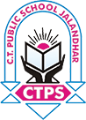

SYLLABUS BOOKLET
SESSION 2020-21
Class IIIrd

ENGLISH
Syllabus. Class 3
Main course book
Books:
Main course book – New Learning to Communicate (3)
Grammar – Grammar Trek
April
MCB
- Puppy in the Well
Grammar
- The Alphabetical Order
- Nouns: Singular and Plural
May
MCB
- There Is Ice Cream in My Eyes
Grammar
- Nouns: Gender
- Nouns: Common, Proper, Possessive
June
MCB
Poem: The Hungry Hen
- Bitter Medicine
Grammar
- Collective Nouns
- Pronouns
July
MCB
4. A Dog Loves Cakes
5. Fire in a Hotel
Grammar
- Adjectives
- Comparison of Adjectives
August
MCB
6. Bear Hug
Poem: On the Bridge
Grammar
1. Main Verbs and Helping Verbs.
2. Has, Have, Had, Do, Does, Did.
September
(Mid term exams)
October
MCB
7. A Shooting Test
Grammar
- Simple Present and Simple Past Tense.
- Adverbs
November
MCB
8. The Bell of Atri
Poem: My Dog
Project-2: A Play with Puppets
Grammar
- Articles: A, An, The.
- Prepositions
December
MCB
- The toy violin 1(Reading)
- The toy violin 2(Reading)
Grammar
1. Conjunctions
2. Interjections.
3. Short Forms
4. Sentence

HINDI

पाठ्यक्रम-2020-21
विषय -हिंदी
कक्षा – तीसरी

पाठ्य पुस्तक-सुनहरी धूप(रचना सागर)
*व्याकरण-मेरी भाषा (ख्याति पब्लिकेशंस)
*सुलेख –(मानसी गुप्ता)
अप्रैल-मई-*पाठ- 1 कौन सिखाता है
*पाठ 2-अनोखा जादू का खेल
*पाठ 3-खेल खेल में
व्याकरण-* लिंग बदलो
*अनेक शब्दों के एक शब्द
*पत्र लेखन -जुर्माना माफी के लिए प्रधानाचार्य जी को पत्र लिखें।
सुलेख पुस्तक: पृष्ठ 3-8
*यूनिट टेस्ट-1
जून-जुलाई-*पाठ 4-वर्षा रानी
*पाठ-5 जन्मदिन का उपहार
*पाठ -6 मैं टीवी हूं
व्याकरण-* वचन बदलो
*अपठित गद्यांश
सुलेख पुस्तक-पृष्ठ ( 9-14)
ग्रीष्मावकाश......
अगस्त- सितंबर-* पाठ 7 बहादुर बच्चे
* पाठ8 पृथ्वी
*पाठ-9 साइकिल मिल गई
व्याकरण- *पाठ 1 -भाषा
* पाठ 2- वर्ण शब्द वाक्य
*अनुच्छेद लेखन
सुलेख पुस्तक- पृष्ठ(15-20)
पुनरावृति- (अप्रैल से अगस्त तक का पाठ्यक्रम)
माध्यमिक परीक्षा..
अक्टूबर-नवंबर-*पाठ10-समस्या ऐसी सुलझी
*पाठ- 11 चतुर तेनालीराम
व्याकरण-*पाठ 3 -मात्राएं
*पाठ 4 -संज्ञा
*चित्र लेखन
*पत्र लेखन
सुलेख पुस्तक -पृष्ठ (21-26)
दिसंबर जनवरी-पाठ 12-पोषम पा भाई पोषम
*व्याकरण- गिनती-(31-50)
*अनुच्छेद लेखन
*व्याकरण- पाठ- 8 विशेषण
पाठ- 9 क्रिया
सुलेख पुस्तक: पृष्ठ ( 27-32)
यूनिट टेस्ट -2
फरवरी-मार्च-*चित्र लेखन
पुनरावृति तथा वार्षिक परीक्षा
नोट: पाठ्य पुस्तक (सुनहरी धूप) से संबंधित सभी पाठों का अभ्यास कार्य करवाया जाएगा।
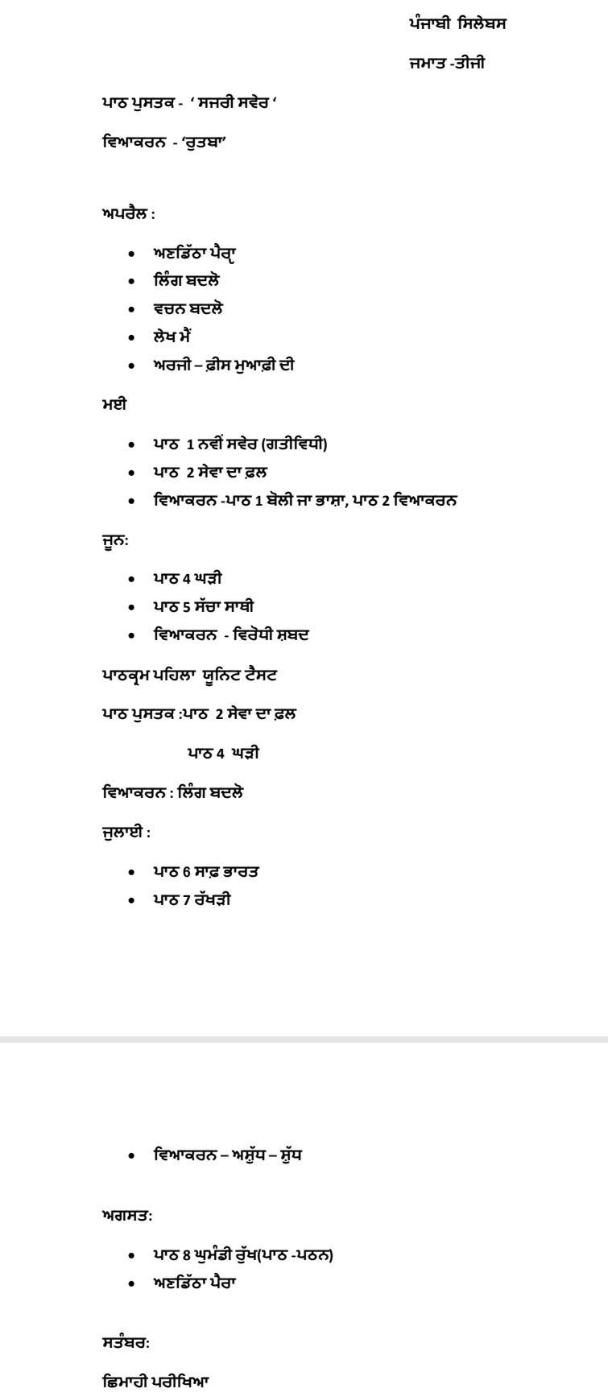
PUNJABI
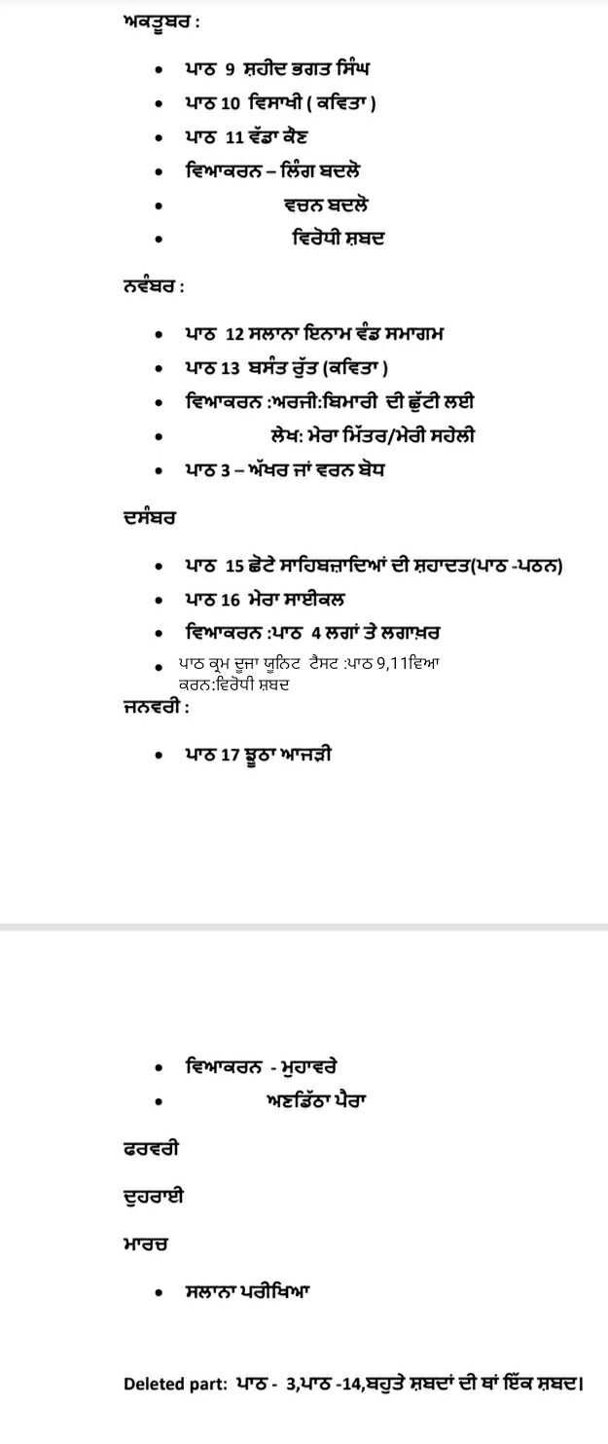
General knowledge
Subject-GK
April
Chapter -1 Our tricolour
Chapter- 2 Constitution of India
Current affairs
May
Chapter-3 States and Capitals of India
Chapter-4 Let's Know The Slogans
July
Chapter-5 Nobel Prize Winners From India
Chapter-6 Folk Dances
August
Chapter-8 Famous Cities of India
Current affairs
Revision of all chapters
September
Half yearly exams
October -November
Chapter-9 Great Indian Personalities
Chapter-10 Indian Sports Star
Chapter-11 The First Indian
Current affairs
December- January
Chapter 12 Famous Gardens of India
Chapter 14 Save Water
February
Revision of chapter 9 to 14 And Currentt affairs
March Final exams
Deleted chapters
Chapter 7,13,15,16
Art and craft
APRIL/MAY
1)Colouring the designers Mayur (page no 3)
2)line drawing in caterpillar (page no 13)
3)Sketch pen technique in cactus (page no 13)
*ACTIVITY *
1) Paper tearing and pasting (collage)(page no 11)
2)Finger panting (page no 7)
3)Monkey and hat (page no 16)
JUNE /JULY
1) Alphabet drawing with(A,D,E,F)(page no 5)
2)Colour the pumpkin house (page 6)
3)Sketch pen line drawing (page 10)
4)Colour the landscape with crayon (page no 22)
*ACTIVITY*
1) Fish on ramp with ice cream stick (page no 15)
2)funny caterpillar pasting of bindis,button goggle eye.
AUGUST/SEPTEMBER
1)Warli art (draw and colours)
2)Number drawing (page no 12)
3)Colour the funny clowns (page no 18)
4)Draw a fruit basket (page no 14)
*ACTIVITY *
1)Rakhi making (page no 24)
2)Paste wood dust in tortoise (page no 33)
3) fly car thumb impressions (page no 35)
OCTOBER/NOVEMBER
1)colour the picture (DUSSEHRA)
2)colour the monsters (page no 26)
3)Typography landscape(page no 28)
4)penguin ( page no 31)
5)How to draw flamingo and colour it (page no 29)
*ACTIVITY *
1)Dragonfly (page no 30)
2)Sweet family with ice cream sticks
DECEMBER/JANUARY
1)Merry Christmas (page no37)
2)Holi (page no 40)
*ACTIVITY *
1)paste the matchsticks and colours the cable car( page no 38)
2)Republic day Activity (page no 20)

MATHEMATICS
Class – III
April to May
Chapters
- - Numbers beyond 999
2 - Addition
June
Unit Test I
June to August
- - Multiplication
- - Subtraction
- - Division September
Mid Term Examination
October to November
11 - Time
- - Fraction
- - Geometry
December
Unit Test II
December to January
10 - Measurement
12 - Money
February: –
Revision of final term syllabus
Unit Test 1:- Chapters - 1, 2
Unit Test 2:- Chapters - 11, 7
Mid Term Syllabus:- Chapters - 1, 2, 3, 4, 5
Final Term Syllabus:-
Chapters – 7, 8, 10, 11, 12
Deleted Chapters
Chapter 6 - More about division
9 - Pattern
13 -Data Handling

EVS

APRIL -MAY
Chapter 1. The Human Body
Chapter2. More About Families
Chapter 3. Our Festivals
JUNE-JULY
Chapter 4 Work Around Us
Chapter 5 Games we Play
Chapter 6 The Food We Eat
SYLLABUS FOR UNIT TEST-1
Chapter 1and chapter 2
AUGUST-SEPTEMBER
Chapter 7 Shelter For All
Chapter 9 Clothes we wear
Chapter 10 India – Our Country

SYLLABUS FOR HALF YEARLY EXAMS
Chapter 3,4,6,9,10
OCTOBER-NOVEMBER
Chapter 11 Living and Non -Living Things
Chapter 12 The Earth and the Sky
Chapter 14 Animals
Chapter 16 Plants Around Us
DECEMBER
Chapter 18 Water in our life
SYLLABUS FOR UNIT TEST-2
Chapter 11,16
JANUARY
Chapter 21 communication
FEBRUARY
Revision for Final Exams
MARCH
FINAL EXAMS
SYLLABUS FOR FINAL EXAMS
Chapter ,12 ,14, 16,18,21
Deleted Chapters
Chapter 8 Pottery
Chapter 13 Mapping our Neighbourhood
Chapter 15 Birds Around Us
Chapter 17 The Early Humans
Chapter 19 Weather and Seasons
Chapter 20 Travelling and Going to places

Computer
Book Name-IT BEANS (KIPS PUBLICATIONS)
April- 2020
Chapter- 1 Parts of Computer
June- 2020
Chapter 2 - Hardware and Software
July 2020
Chapter 3 - T4x - Paint
August 2020
Chapter 4 - Understanding Windows
September 2020
MID TERM EXAMINATION
Chapter - 1 to 4
October 2020
Chapter 5 - Working with Paint
November 2020
Chapter 6 - The keyboard
December 2020
Chapter 7 - Microsoft word 2010
January 2020
Chapter 8 - log On to logo
February - Revision for final examination
March - Final Term Examination
Chapter - 5 Working with Paint
Chapter -6 The keyboard
Chapter -7 Microsoft word 2010
Chapter -8 Log On to logo

