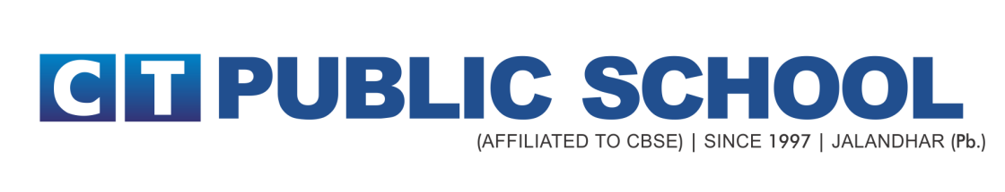
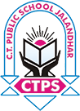

Class X

Minor Subjects Datesheet

Date | Day | Subject
20-11-2021 | Saturday | Punjabi
23-11-2021 | Tuesday | *Introduction to Financial Marketing  *Automotive
25-11-2021 | Thursday | Information Technology

SECONDARY SCHOOL EXAMINATION

TERM 1 (2021-22)

CLASS X DATE SHEET- MAJOR SUBJECTS

DAY, DATE AND TIME | SUBJECT CODE | SUBJECT NAME

TUESDAY, 30th NOVEMBER, 2021
11:30 AM – 1:00 PM | 087 | SOCIAL SCIENCE

THURSDAY, 2nd DECEMBER, 2021
11:30 AM – 1:00 PM | 086 | SCIENCE

SATURDAY, 4th DECEMBER, 2021
11:30 AM – 1:00 PM | 041 | MATHEMATICS STANDARD
 | 241 | MATHEMATICS BASIC

THURSDAY, 9th DECEMBER, 2021
11:30 AM – 1:00 PM | 085 | HINDI COURSE-B

SATURDAY, 11th DECEMBER, 2021
11:30 AM – 1:00 PM | 184 | ENGLISH (LANG & LIT.)

