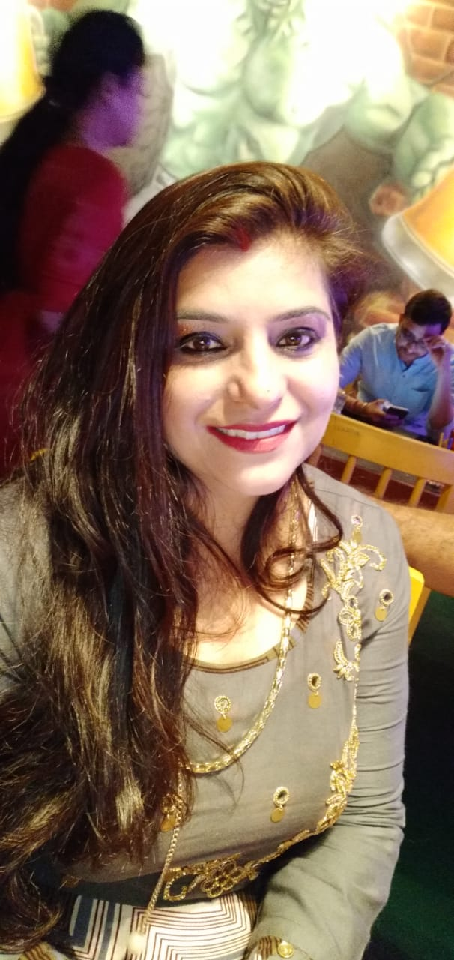
Art is something that can attract a person to observe or view due to it beauty and its presentable look. The art also must be a work that can communicate and useful between a viewer and the artist. But of all the beauty in the world, the works of beauty by the Mighty Allah is the infirmity and with His approval the human can create a beautiful art. As said by Hashim Musa (1996) about the concept of arts:
'Art, for human is the occasion for expression, talking, verbalization and speech, and for the representation of beauty, truth and perfection. However, the real height of beauty truth and perfection is Allah and all His creation." 1

To express the need in art, an artist should know how to communicate with the viewer, spectator or observer through his art as the medium. The communications that created by the artist have made the art useful and sometimes meaningful for human. Craft is Art, art done by the artist that so beautiful and useful to the need of its observer. Craft, did have all the concept mention.

Bhawna Arora
Art Teacher

