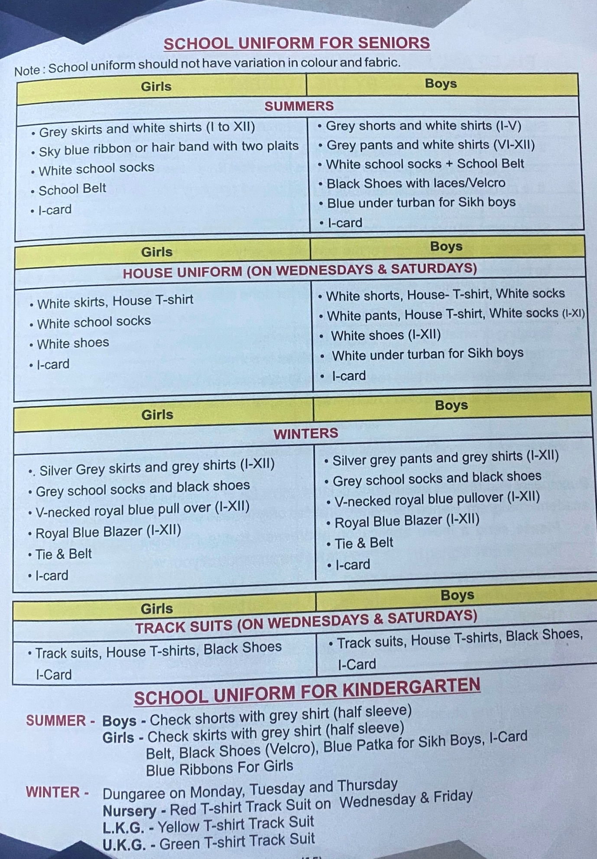

School Uniform is available in following stores:-
- Sungrace Uniform, Model Town, Jalandhar
- Sunflag Uniform, Industrial Area, Jalandhar
- Bansal Brothers, Jyoti Chowk, Jalandhar
- Vardi House, Kapurthala Road, Jalandhar
- Cash n Carry, Greater Kailash, Maqsudan, Jalandhar

