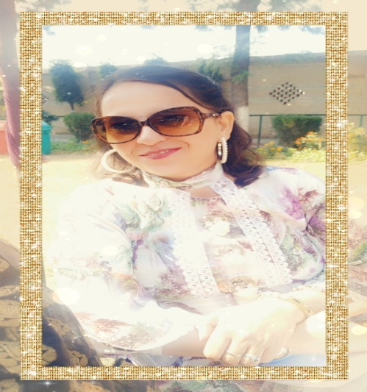
Healthy children are like blooming flowers in the garden. They are the pillars of our future. Teachers, parents and community can play a big role in providing healthcare and creating awareness for the children using all-inclusive approach. It is easy to approach a child during schooling where teachers can impart health and life skills education and make the child aware of various health hazards he or she may face. It attempts to make people more hardy, disease resistant and more resilient when illness occurs. It is important for a parent or guardian,to have good working knowledge of child health care,including hygiene, feeding,growth and development and issues such as behaviour problems, drugs,sex and alcohol abuse. Parents should be able to prevent the ailment before the onset of symptoms. They should be able to recognise the early signs and symptoms and finally treat the ailment. In fact parents should be aware that they can prevent an illness by providing safe drinking water,a balance diet,appropriate exercises and immunization. They should also help them develop life skills (self-esteem, decision making ,goal setting ,effective communication, stress management, character building and sensory motor skills) ensuring they become an integral part of each child's life and personality .Good health makes you feel positive and enables you to take on the world.

Baruna Sadana
English Teacher

