CBSE CURRICULUM 2020-21

XI COMMERCE

SYLLABUS OF COMPUTER SCIENCE
CLASS XI

Unit I: Computer Systems and Organisation
● Basic computer organisation: description of a computer system andmobile system, CPU, memory, hard disk, I/O, battery.
● Types of software: Application software, System software and Utility
software.
● Memory Units: bit, byte, MB, GB, TB, and PB.
● Boolean logic: NOT, AND, OR, NAND, NOR, XOR, NOT, truth tables andDe Morgan’s laws, Logic circuits
● Number System: numbers in base 2, 8, 16 and binary addition.
● Encoding Schemes : ASCII, ISCII and Unicode 2
● Concept of Compiler and Interpreter
● Operating System (OS) - need for an operating system, brief introductionto functions of OS, user interface
Unit II: Computational Thinking and Programming - 1
Introduction to Problem solving: Problem solving cycle - Analysing a problem,designing algorithms and representation of algorithm using flowchart andpseudo-code.
Familiarization with the basics of Python programming: a simple “hello world"program, the process of writing a program (Interactive & Script mode),running it and print statements; simple data-types: integer, float and string.
● Features of Python, Python Character Set, Token & Identifiers, Keywords,Literals, Delimiters, Operators.
● Comments: (Single line & Multiline/ Continuation statements), Clarity &Simplification of expression
● Introduce the notion of a variable and methods to manipulate it (concept ofL-value and R-value even if not taught explicitly).
● Knowledge of data types and operators: accepting input from the console,assignment statement, expressions, operators and their precedence.
● Operators & types: Binary operators-Arithmetic, Relational Operators,Logical Operators, Augmented Assignment Operators.
● Execution of a program, errors- syntax error, run-time error and logicalerror.
● Conditional statements: if, if-else, if-elif-else; simple programs: e.g.:absolute value, sort 3 numbers and divisibility of a number.
● Notion of iterative computation and control flow: for(range(),len()), while,using flowcharts, suggested programs: calculation of simple and compoundinterests, finding the factorial of a positive number etc.
● Strings: Traversal, operations – concatenation, repetition, membership;functions/methods–len(), capitalize(), title(), upper(), lower(), count(), find(),index(), isalnum(), islower(), isupper(), isspace(), isalpha(), isdigit(), split(), partition(), strip(), lstrip(), rstrip(), replace(); String slicing.
● Lists: Definition, Creation of a list, Traversal of a list. Operations on a list -concatenation, repetition, membership; functions/methods–len(), list(),append(), extend(), insert(), count(), index(), remove(), pop(), reverse(), sort(),min(), max(), sum(); Lists Slicing; Nested lists; finding the maximum, minimum,mean of numeric values stored in a list; linear search on list of numbers andcounting the frequency of elements in a list.
● Tuples: Definition, Creation of a Tuple, Traversal of a tuple. Operations ona tuple - concatenation, repetition, membership; functions/methods –len(), tuple(), count(), index(), sorted(), min(), max(), sum(); Nested tuple;Tuple slicing; finding the minimum, maximum, mean of values stored in atuple; linear search on a tuple of numbers, counting the frequency ofelements in a tuple.
● Dictionary: Definition, Creation, Accessing elements of a dictionary, add anitem, modify an item in a dictionary; Traversal, functions/methods – len(),dict(), keys(), values(), items(), get(), update(), del(), del, clear(),fromkeys(), copy(), pop(), popitem(), setdefault(), max(), min(), count(),sorted() copy(); Suggested programs : count the number of times acharacter appears in a given string using a dictionary, create a dictionary
with names of employees, their salary and access them.
● Introduction to Python modules: Importing math module (pi, e, sqrt, ceil,floor, pow, fabs, sin, cos, tan); random module (random, randint,randrange), statistics module (mean, median, mode).
Unit III: Society, Law and Ethics
● Cyber safety: safely browsing the web, identity protection, confidentiality,social networks, cyber trolls and bullying.
● Appropriate usage of social networks: spread of rumours, and commonsocial networking sites (Twitter, LinkedIn, and Facebook) and specificusage rules.
● Safely accessing web sites: adware, malware, viruses, trojans
● Safely communicating data: secure connections, eavesdropping, phishingand identity verification.
● Intellectual property rights, plagiarism, digital rights management, and
licensing (Creative Commons, GPL and Apache), open source, open data, privacy.
● Privacy laws, fraud; cyber-crime- phishing, illegal downloads, child
pornography, scams; cyber forensics, IT Act, 2000.
● Technology and society:
● understanding of societal issues and cultural changes induced bytechnology.
● E-waste management: proper disposal of used electronic gadgets.
● Identity theft, unique ids and biometrics.
● Gender and disability issues while teaching and using computers.

ECONOMICS(Code No. 030)

*PartA*

Unit 1
Introduction

what is economics its meaning scope functions and importance of statistics in economics

*Unit 2*
Collection and organisation and presentation of data

Collection of data its source of data that is primary and secondary, how basic data is collected,, concepts of sampling, methods of calculating data, some important sources of secondary data, census of India and National sample survey organisation.
Organisation of data its meanings and types of variables and frequency distribution
Presentation of data its tabular presentation and diagrammatic representation of data. Geometrical forms, frequency diagrams, arithmetic line graph.

*Unit 3*
Statistical tools and interpretation

Measures of Central tendency, mean simple and weighted, median and mode
Measures of dispersion absolute dispersion standard dispersion relative dispersion.
Correlation its meaning and properties it scatter diagram,
Measures of correlation karl Pearson method ,two variable ungrouped data.
Introduction to index number its meaning and types and wholesale price index, consumerprice index and uses of index number and inflation and index numbers

*PartB*

Introductory of microeconomics

*Unit4*

Introduction

meaning of microeconomics and macroeconomics its positive and normative economics,Central problems of an economy what how and for whom to produce,concepts of production possibility Frontier and opportunity cost.

*Unit 5*

Consumer equilibrium and demand

Consumer equilibrium its meaning of utility, marginal utility and law of diminishing marginal utility, conditions of consumer equilibrium using marginal utility analysis
Indifference curve analysis of consumer equilibrium its consumer budget, budget set and budget line, preferences of the consumer and conditions of consumer equilibrium
Demand and market demand, determinants of demand, demand schedule, demand curve and its slope, movement along and shifts in the demand,price elasticity of demand its factors affecting price elasticity of demand and measurement of price elasticity of demand through percentage change method.

*Unit 6*

Producer behaviour and supply

meaning of production function short run and long run, total product,average product and marginal product and returns to factor, cost ,short run cost , total cost, total fixed cost, total variable cost, average cost, average fixed cost, average variable cost, marginal cost its meaning and their relationships
Revenue its total and average and marginal revenue and their relationships.
producer equilibrium its meaning and its conditions in terms of marginal revenue and marginal cost
Supply, market supply, determinants of supply, supply schedule, supply curve and its slope, movement along and shifts in the supply, price elasticity of, measurements of price elasticity of supply through percentage change method

*Unit 7*

Forms of market and price determination under perfect competition with simple applications

perfect competition its features its determinants of market equilibrium and its effects of shift in demand and supply.
Simple applications of demand and supply , price ceiling and price floor

*Deleted syllabus*
Unit 3

Range, quartile deviation, mean deviation, coffee cient of quartile deviation,coefficient of mean deviation and Lawrence curve its meaning and construction and application
Spearman rank correlation
Index of industrial production

*Unit 7*
Other market forms-monopoly, monopolistic competition, oligopoly and their meaning and features.

*Referred books*
Microeconomics. NCERT.

Statistics for economics
NCERT

VK publication
TR Jain VK ohri

ACCOUNTANCY (Code No. 055)
PART A: FINANCIAL ACCOUNTING - I
Unit-1: Theoretical Frame Work
Introduction to Accounting Accounting- concept, objectives, advantages• and limitations, types of accounting information; users of accounting information and their needs. Qualitative Characteristics of Accounting Information. Role of Accounting in Business.
Basic Accounting Terms- Business• Transaction, Capital, Drawings. Liabilities (Non Current and Current). Assets (Non Current, Current); Fixed assets (Tangible and Intangible), Expenditure (Capital and Revenue), Expense, Income, Profit, Gain, Loss, Purchase, Sales, Goods, Stock, Debtor, Creditor, Voucher, Discount (Trade discount and Cash Discount)
Theory Base of Accounting
Fundamental accounting assumptions:• GAAP: Concept Business Entity, Money Measurement, Going• Concern, Accounting Period, Cost Concept, Dual Aspect, Revenue Recognition, Matching, Full Disclosure, Consistency, Conservatism, Materiality and Objectivity System of Accounting. Basis of Accounting:• cash basis and accrual basis Accounting Standards: Applicability in IndAS• Goods and Services Tax (GST):• Characteristics and Objective.
Unit-2: Accounting Process
Recording of Business Transactions
Voucher and Transactions:
- Source documents and Vouchers, Preparation of Vouchers, Accounting Equation Approach: Meaning and Analysis, Rules of Debit and Credit.
- Recording of Transactions: Books of Original entry - Journal
- Special Purpose books:
• Cash Book: Simple, cash book with bank column and petty cashbook
•Purchases book, Sales book
• Purchases return book• Sales return book
• Note: Including trade discount, freight and cartage expenses for simple GST calculation.
- Ledger: Format, Posting from journal and
- subsidiary books, Balancing of accounts
Bank Reconciliation Statement: Need and preparation
Depreciation: Concept, Features, Causes,• factors Other similar terms: Depletion and• Amortisation Methods of Depreciation:• i. Straight Line Method (SLM) ii. Written Down Value Method (WDV)
- Note: Excluding change of method Difference between SLM and WDV;• Advantages of SLM and WDV
Provisions and Reserves: Difference• Types of Reserves:• Revenue reserve ii. Capital reserve iii. General reserve iv. Specific reserve Difference between capital and revenue• reserve
Accounting for Bills of Exchange
- Bill of exchange and Promissory Note:• Definition, Specimen, Features, Parties. Difference between Bill of Exchange and• Promissory Note
Terms in Bill of Exchange:
i. Term of Bill
ii. Accommodation bill (concept)
iii. Days of Grace
iv. Date of maturity
v. Discounting of bill
vi. Endorsement of bill
vii. Bill after due date
viii. Negotiation
ix. Bill sent for collection
x. Dishonour of bill
xi. Retirement of bill
Trial balance and Rectification of Errors
Trial balance: objectives and preparation• (Scope: Trial balance with balance method only)
Errors: types-errors of omission, commission,• principles, and compensating; their effect on Trial Balance.
Detection and rectification of errors;• preparation of suspense account.
Part B: Financial Accounting - II
Unit 3: Financial Statements of Sole Proprietorship
Financial Statements - Meaning, objectives and importance; Revenue and Capital Receipts; Revenue and Capital Expenditure; Deferred Revenue expenditure.
- Trading and Profit and Loss Account: Gross Profit, Operating profit and Net profit. Preparation.
- Balance Sheet: need, grouping and marshalling of assets and liabilities Preparation.
- Adjustments in preparation of financial statements with respect to closing stock, outstanding expenses, prepaid expenses, accrued income, income received in advance, depreciation, bad debts, provision for doubtful debts, provision for discount on debtors, Abnormal loss, Goods taken for personal use/staff welfare, interest on capital and managers commission.
- Preparation of Trading and Profit and Loss account and Balance Sheet of a sole proprietorship with adjustments.
Incomplete Records
- Features, reasons and limitations.
- Ascertainment of Profit/Loss by Statement of Affairs method.
- Difference between accounts from incomplete records and Statement of Affairs.
Unit 4: Computers in Accounting
- Introduction to computer and accounting information system {AIS}: Introduction to computers (elements, capabilities, limitations of computer system)
- Introduction to operating software, utility, software and application software.
- Automation of accounting process: meaning Stages in automation: (a) Accounting process in a computerised environment; comparison between manual accounting process and computerised accounting process, (b) Sourcing of accounting software; kinds of software: readymade software; customised software and tailor-made software; generic considerations before sourcing accounting software (c) creation of account groups and hierarchy (d) generation of reports - trial balance, profit and loss account and balance sheet.
Part C: Project Work (Any One)
1. Collection of source documents, preparation of vouchers, recording of transactions with the help of vouchers.
2. Preparation of Bank Reconciliation Statement with the given cash book and the pass book with twenty to twenty-five transactions.
3. Comprehensive project of any sole proprietorship business. This may state with journal entries and their ledgering, preparation of Trial balance. Trading and Profit and Loss Account and Balance Sheet. Expenses, incomes and profit (loss), assets and liabilities are to be depicted using pie chart / bar diagram.

Topics Deleted
Bank Reconciliation Statement
- Bank Reconciliation Statement with Adjusted Cash Book
Accounting for Bills of Exchange
- Retirement of Bill
- Renewal of Bill
Incomplete records
- Difference between accounts from incomplete records and Statement of Affairs
- Preparation of Trading, Profit and Loss Account and Balance sheet.
UNIT 4 – Computers in Accounting
- Introduction to operating software , utility software and application software. Introduction to Accounting information system as a part of MIS.
- Stages in automation (a) Accounting process in a computerised environment; comparison between manual accounting process and computerised accounting process, (b) Sourcing of Accounting software; kinds of software; generic considerations before sourcing accounting software (c) creation of account groups and hierarchy (d) generation of reports P/L, B/S.
Project work
- 5 lectures are reduced in the project work.
- Total lectures reduced are 45.

BUSINESS STUDIES (Code No. 054)
Part A: Foundation of Business
Concept includes meaning and features
Unit 1: Evolution and Fundamentals of Business
History of Trade and Commerce in India: Indigenous Banking System, Rise of Intermediaries, Transport, Trading Communities: Merchant Corporations, Major Trade Centres, Major Imports and Exports, Position of Indian Sub-Continent in the World Economy.
Business – meaning and characteristics
Objectives of business
Classification of business activities - Industry and Commerce
Industry-types: primary, secondary, tertiary Meaning and subgroups
Commerce-trade: (types-internal, external; wholesale and retail) and auxiliaries to trade; (banking, insurance, transportation, warehousing, communication, and advertising) – meaning
Business risk-Concept
Unit 2: Forms of Business organizations
Sole Proprietorship-Concept, merits and limitations.
Partnership-Concept, types, merits and limitation of partnership, registration of a partnership firm, partnership deed. Types of partners
Hindu Undivided Family Business: Concept Understand the concept of Hindu• Undivided Family Business.
Cooperative Societies-Concept, merits, and limitations.
Company - Concept, merits and limitations; Types: Private, Public and One Person Company – Concept
Formation of company - stages, important documents to be used in formation of a company
Unit 3: Public, Private and Multinational Company
Public sector and private sector enterprises – Concept Develop an understanding of Public sector and private sector enterprises
Forms of public sector enterprises: Departmental Undertakings, Statutory Corporations and Government Company.
Unit 4: Business Services
Business services – meaning and types. Banking: Types of bank accounts - savings, current, recurring, fixed deposit and multiple option deposit account Understand the meaning and types• of business services. Discuss the meaning and types of• Business service
Banking Develop an understanding of• difference types of bank account. Banking services with particular reference to Bank Draft, Bank Overdraft, Cash credit. E-Banking meaning, Types of digital payments Develop an understanding of the• different services provided by banks
Insurance – Principles. Types – life, health, fire and marine insurance – concept
Unit 5: Emerging Modes of Business
Give the meaning of e-business.•E - business: concept, scope and benefits
Discuss the scope of e-business.• Appreciate the benefits of E- business• Distinguish e-business from• traditional business.
Business Process Outsourcing (BPO): Concept, need and scope
Unit 6: Social Responsibility of Business and Business Ethics
State the concept of social•Concept of social responsibility responsibility.
Examine the case for social•Case of social responsibility responsibility.
Responsibility towards owners, investors, consumers, employees, government and community.
Part B: Finance and Trade
Unit 7: Sources of Business Finance
State the meaning, nature and•Concept of business finance
Importance of business finance.
Owners’ funds- equity shares, preferences share, retained earnings, Global Depository receipt (GDR), American Depository Receipt (ADR) and International Depository Receipt (IDR) – concept
Borrowed funds: debentures and bonds, loan from financial institution and commercial banks, public deposits, trade credit, Inter Corporate Deposits (ICD).
Unit 8: Small Business and Enterprises
Entrepreneurship Development (ED): Concept, Characteristics and Need. Process of Entrepreneurship Development.
Start-up India Scheme, ways to fund start-up. Intellectual Property Rights and Entrepreneurship Understand the concept of Entrepreneurship Development (ED)
Intellectual Property Rights Small scale enterprise as defined by MSMED Act 2006 (Micro, Small and Medium Enterprise Development Act)
Understand the meaning of small business Role of small business in India with special reference to rural areas.
Government schemes and agencies for small scale industries: National Small Industries Corporation (NSIC) and District Industrial Centre (DIC) with special reference to rural, backward areas
Unit 9: Internal Trade
Internal trade - meaning and types services rendered by a wholesaler and a retailer.
Types of retail-trade-Itinerant and small scale fixed shops retailers.
Large scale retailers-Departmental stores, chain stores – concept
Unit 10: International Trade
International trade: concept and benefits
Documents involved in International Trade; indent, letter of credit, shipping order, shipping bills, mate’s receipt (DA/DP)
World Trade Organization (WTO) meaning and objectives.
Unit 11: Project Work
As per CBSE guidelines.
DELETED TOPICS
Part A – Foundation of Business
- CH 2 – Forms of Business :- Choice of form of Business Organisation.
- CH 3 – Public, Private and Global Enterprises:-
Global Enterprises : Features; Joint ventures; Public Private Partnership : Concept
- CH 4 – Business Services :- Postal services- Mail, Registered post , parcel, speed post, courier - meaning
- CH 5 – Emerging Modes of Business :- Business Process outsourcing (BPO) Concept , need and scope
- CH 6 – Social responsibilities of Business and Business Ethics :- Business ethics – concept and elements.
Part B – Finance and Trade
- CH 7 – Sources of Business Finance :- Borrowed funds – ICD – Concepts
- CH 9 – Internal Trade – Types of retail trade- Itinerants and small scale fixed shops retailers
GST (Goods and services tax) - Concept
- CH 10 – External Trade:-
Export trade – Meaning and procedure
Import trade – Meaning and procedure
Documents involved in International Trade ; indent, letter of credit, shipping order, shipping bills, mate’s receipt
World Trade Organisation(WTO) : Meaning and objectives

ENGLISH CORE (CODE NO. 301)

PART A - 40 MARKS
Reading 18 Marks
I. Multiple Choice questions based on one unseen passage to assess comprehension,
interpretation and inference. Vocabulary and inference of meaning will also be
assessed. The passage may be factual, descriptive or literary. Ten out of eleven
questions to be done. (10x1=10 Marks)
II. Multiple Choice questions based on one unseen case-based factual passage with
verbal/visual inputs like statistical data, charts etc. Eight out of Nine questions to be
done. (8x1=8 Marks)
Note: The combined word limit for both the passages will be 600-750.
Grammar 8 Marks
III. Multiple choice questions on Gap filling (Determiners, Tenses)
IV. Multiple choice questions on re-ordering/transformation of sentences
(Total eight questions to be done out of the ten given).
Literature Section 14 Marks
V. Multiple Choice questions from an extract from Poetry from Hornbill to assess
comprehension and appreciation. Any 1 out of 2 extracts to be done.(3x1=3)
VI. Multiple Choice questions based on two Prose extracts, out of the three given, from
Prose (Hornbill as well as Snapshots to assess comprehension and appreciation.
( 6x1=6)
VII. Text based Multiple Choice Questions to assess comprehension, analysis and
interpretation, from Prose and Poetry. Five questions out of six to be done. (5x1=5)

PART B - 40 MARKS
Reading Section: 8 Marks
Q1. Note Making and Summarization based on a passage of approximately 200-250
words.
I. Note Making: 5 Marks
○ Title: 1
○ Numbering and indenting: 1
○ Key/glossary: 1
○ Notes: 2
II. Summary (up to 50 words): 3 Marks
○ Content: 1
○ Expression: 1
Writing Section: 16 Marks
Q2. Short writing task -Notice writing up to 50 words. One out of the two given
questions to be answered (3 Marks: Format : 1 / Content : 1 / Expression : 1)
Q3. Short writing task –Poster up to 50 words. One out of the two given questions to be
answered.(3marks:Format : 1 / Content : 1 / Expression : 1)
Q4. Letters based on verbal/visual input, to be answered in 120-150 words. Business or
official letters (for making enquiries, registering complaints, asking for and giving
information, placing orders and sending replies), letter to the school or college
authorities, regarding admissions, school issues, requirements / suitability of courses,
etc. One out of the two given questions to be answered (5 Marks: Format: 1 / Content:
2 / Expression: 2)
Q5 .Writing composition based on visual/verbal inputs in 120-150 words. May be
descriptive / argumentative in nature such as speech/debate. The theme should be
contemporary topical issues. One out of the two given questions to be answered.
(5 Marks: Format: 1 / Content: 2 / Expression: 2)
Literature Section: 16 Marks
Q6. Two Short answer type question(one from Prose and one from Poetry from the
book Hornbill), out of four, to be answered in 30-40 words. Questions should elicit
inferential responses through critical thinking. (2x2=4)
Q7. One Short answer type question, from Prose (Snapshots), to be answered in 40-
50 words. Questions should elicit inferential responses through critical thinking. Any 1
out of 2 questions to be done. (1x2=2)
Q 8. One Long answer type question, from Prose/poetry (Hornbill), to be answered in
120-150 words to assess global comprehension and extrapolation beyond the text.
Questions to provide evaluative and analytical responses using incidents, events,
themes as reference points. Any 1 out of 2 questions to be done.(1x5=5)
Q.9 One Long answer type question, based on the chapters from the book Snapshots,
to be answered in 120-150 words to assess global comprehension and extrapolation
beyond the text. Questions to provide evaluative and analytical responses using
incidents, events, themes as reference points. Any 1 out of 2 questions to be
done.(1x5=5)
_______________

Deleted Topics
Writing
● Classified Advertisements,
● Letters to the editor (giving suggestions/opinions on an issue) Provide
realistic context in the form of newspaper report/article to which the
students may respond.
● Application for a job with a bio-data or résumé
● Article & Report Writing
● Narrative
Grammar
● Modals
● Clauses
● Change of Voice
● Error Correction, editing task/cloze passages
Literature
Hornbill
● Father To Son
● The Adventure
Snapshots
● The Ghat of the Only World
● The Tale of Melon City
Prescribed Books
1. Hornbill: English Reader published by National Council of Education Research and
Training, New Delhi
2. Snapshots: Supplementary Reader published by National Council of Education
Research and Training, New Delhi

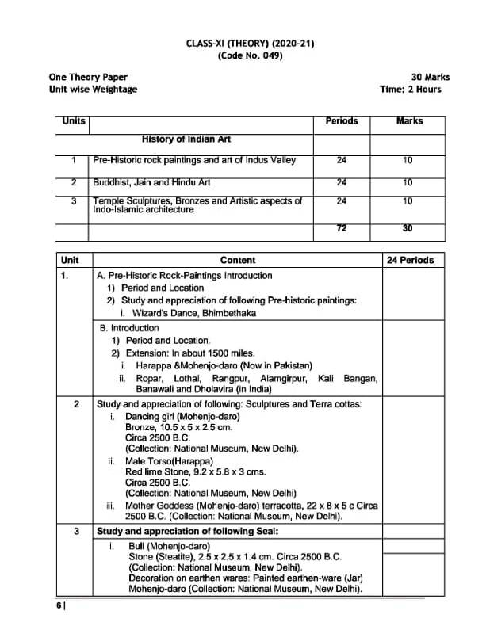

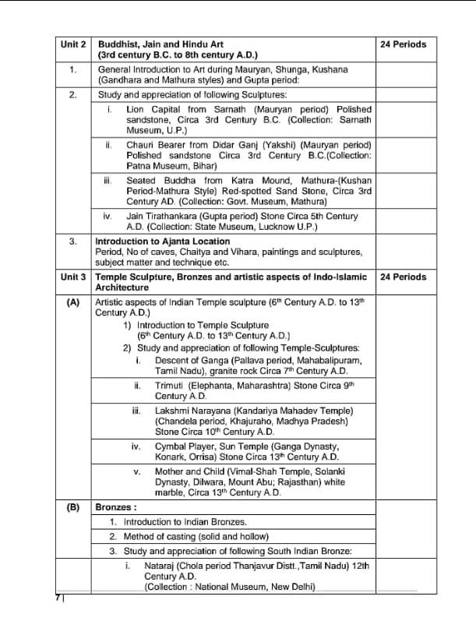

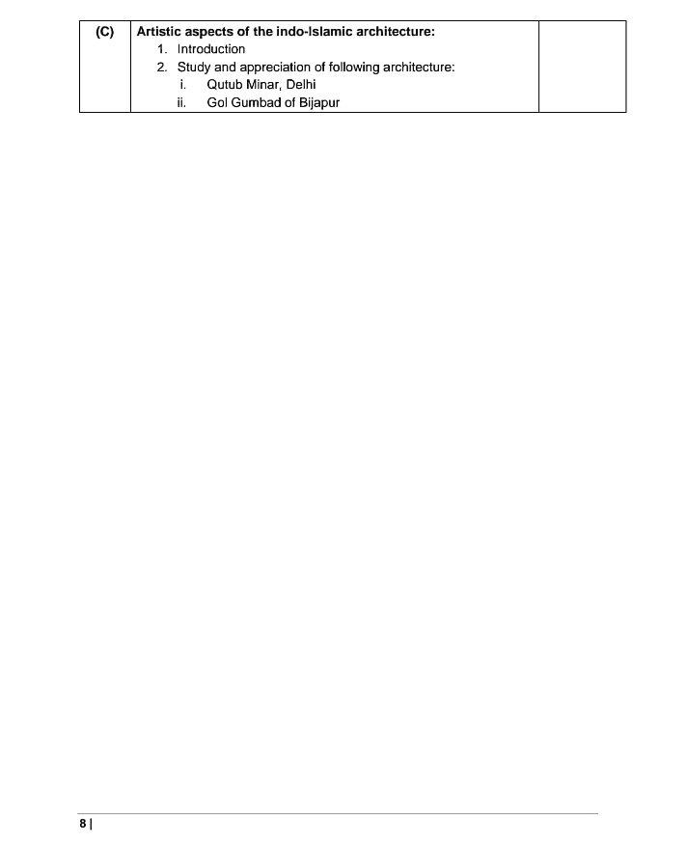

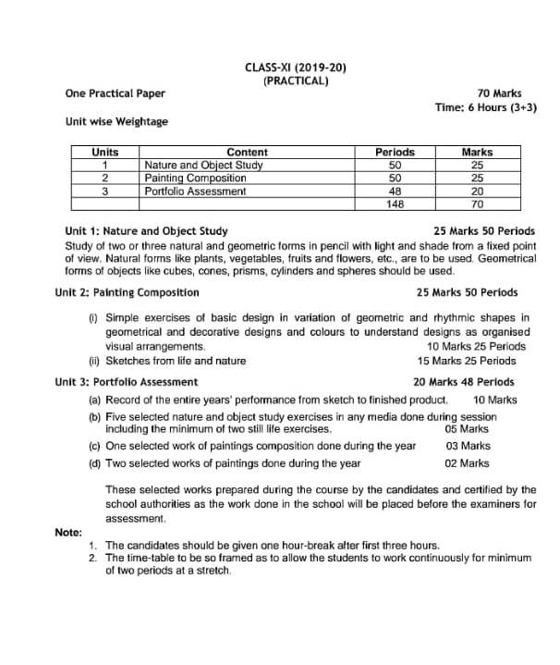

PHYSICAL EDUCATION
CLASS-XI

THEORY
UNIT-I Changing Trends and Career In Physical Education
1.1 Meaning and Definition of Physical education
1.2 Aims and Objectives of Physical Education
1.3 Career options in Physical Education
1.4 Competitions in various Sports at National and International Level
1.5 Khelo India Programme
UNIT-II Olympic Value Education
2.1 Olympics, Paralympics and Special Olympics
2.2 Olympic Symbols, Ideals, Objectives and Value of Olympism
2.3 International Olympic Committee
2.4 Indian Olympic Association
UNIT-III Physical Fitness, Wellness & Lifestyle
3.1 Meaning and Importance of Physical Fitness, Wellness and Lifestyle
3.2 Components of Physical Fitness and Wellness
3.3 Components of Health Related Fitness
UNIT-IV Physical Education & Sports for CWSN (Children with Special needs-Divyang)
4.1 Aims and Objectives of Adaptive Physical Education
4.2 Organizations Promoting Adaptive Sports (Special Olympics Bharat; Paralympics; Deaflympics)
4.3 Concept of Inclusion, Its Need and Implementation
4.4 Role of various professionals for children with special need (Counsellor, Occupational Therapist, Physiotherapist, Physical Education Teacher, Speech Therapist & Special Educator)
UNIT-V Yoga
5.1 Meaning and Importance of Yoga
5.3 Introduction- Asanas, Pranayama, Meditation and Yogic Kriyas
5.5 Relaxation Techniques for Improving Concentration-Yoga Nidra
(5.2 &5.4 deleted)
UNIT-VI Physical Activity and Leadership Training
6.1 Leadership Qualities and Role of a Leader
6.2 Creating Leaders through Physical Education
6.3 Meaning, Objectives and Types of Adventure Sports (Rock Climbing, Trekking, River Rafting, Mountaineering, Surfing and Para Gliding)
6.4 Safety Measures to prevent Sports Injuries
UNIT-VII Test, Measurement and Evaluation
7.1 Define Test, Measurement and Evaluation
7.2 Importance of Test, Measurement and Evaluation in Sports
7.3 Calculation of BMI and Waist Hip Ratio
7.4 Somato Types (Endomorphy, Mesomorphy and Ectomorphy)
7.5 Measurement of Health Related Fitness
UNIT-VIII Fundamentals of Anatomy, Physiology and Kinesiology
*Whole unit deleted
UNIT-IX Psychology & Sports
9.1 Definition and Importance of Psychology in Physical Education and Sports
9.2 Define and Differentiate between Growth and Development
9.3 Developmental Characteristics at Different Stages of Development
9.4 Adolescent Problems and their Management
UNIT-X Training and Doping In Sports
10.1 Meaning and concept of Sports Training
10.2 Principles of Sports Training
10.3 Warming Up and Limbering Down
10.4 Skill, Technique and Style
10.5 Concept and Classification of Doping
10.6 Prohibited Substances and their Side Effects
10.7 Dealing with Alcohol and Substance Abuse

